**Heroes and Villains (possible game name?)**

**Treatment**

**Name of the game**

Heroes and Villains

**Level duration**: TBA

**Time to complete production:** 35 weeks

**Genre/category:**  Superhero/ Action

**Game play:** Stopping crime around the city using combat and weapons, increase superhero status/ take on the city as a criminal mastermind causing havoc.

**Camera:** 3rd person

**Setting:** present day, New York style city

**Deadline:**  tba

**Platform:**  Xbox

**Resources:** Unity, 3DS Max, Photoshop, Mud box, Z Brush, Blender

**Characters:**

**Description:** Fight crime in the city as a vigilante, working your status up to superhero.

**Music:**  TBA

**Synopsis:**

Story one: As a young man who dislikes the crime and corruption in the city, you take on the evil from within, taking down criminal masterminds along with petty thieves.

Story two: As a petty thief with a corrupt past, you attempt to rob banks and cause chaos in the city. Starting as a petty criminal you work your way up to criminal mastermind taking on the police force of the city.

**Why create this game?**

Not only is this a game, it also follows a strong narrative which many games find hard to do at times. The idea behind this is to keep the player interested until they have reached the end of the story. Along with two stories, the player can free roam the city environment and play as they please; meaning the game effectively has no end.

**Where does the game take place?**

The game takes place in present USA. The city although fictional will bare resemblances to New York. The levels of the game will take place in different areas/ buildings of the city.

**Main focus**

The main focus of the game is to Stop crime and along the way increase your status as a vigilante. For the second storyline the focus is to become a Criminal mastermind.

**Target audience**

The intended target audience for this game would be 13+. Due to the nature of combat and mild violence it wouldn’t be suitable for anyone below this age. We do not want to promote crime so again we would not want the game to influence the behaviour of small children.

**Storyline 1**

Young Jeremy jones is a 17 year old student from New city (names subject to change). Scared for his life when walking around the city, he wants to eliminate crime and violence in his home town. With access to an old police radio he finds crimes and attempts to stop the criminals in their tracks. With the physique of a 12 year old he finds it incredibly difficult to do almost anything at first and so begins a training regime that allows him to fight crime.

**Storyline 2**

Jack Prendergast is a 17 year old orphan from new city. With a troubled background and no family he turns to a life of crime. Starting out as a petty criminal robbing people on the streets, he attempts to work on a plan to take out the entire police force as well as the city.

**Player controls**

The platform we hope to produce the game for is the Xbox 360. Below is an image of the Xbox controller along with our control configuration for the game.

Crouch/ Jab

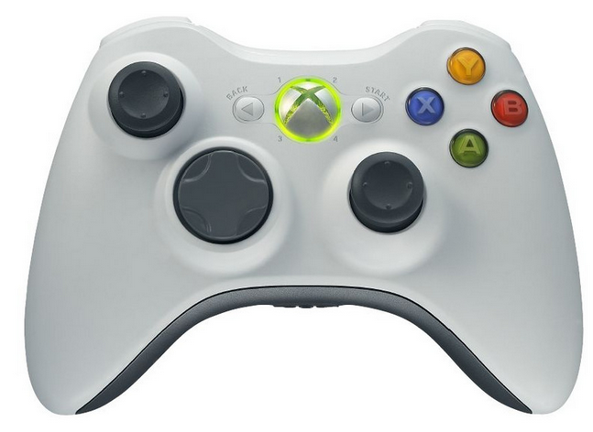

Drop object /left hook

Jump/Kick

Pick up object /right hook

Move

Look up, down

<http://www.google.co.uk/imgres?um=1&hl=en&safe=off&sa=N&tbm=isch&tbnid=4_hDeKP2NrE0xM:&imgrefurl=http://pective.com/pic/xbox-360-controller-2&docid=cVycldgvWU1tqM&imgurl=http://pective.com/m/xbox-360-controller-2&w=800&h=577&ei=J8xiUJyXENOr0AWzpoHACw&zoom=1&iact=hc&vpx=550&vpy=156&dur=612&hovh=191&hovw=264&tx=112&ty=116&sig=112332603636334345089&page=1&tbnh=133&tbnw=184&start=0&ndsp=18&ved=1t:429,r:2,s:0,i:77&biw=1366&bih=667>

**Characters**

Name: Jeremy Jones

Sex: male

Age: 17

Height: 5ft9

Occupation: Student

Description: geeky teenager, Glasses and skinny build with lack of muscle.

Game info:

This is the lead character in the superhero storyline.

Inspired character looks:

Peter Parker (Spiderman)



<http://www.comicbookmovie.com/fansites/MyPersonalInsaneAsylum/news/?a=63106>

Throughout the game our player will change his appearance. We hope that by the end of the game he will have bigger muscles, in order to do this we would need to create a number of models for this one character. Name:

Sex: male

Age: 17

Height: 6ft

Occupation: Student

Description: Muscular and broad with short hair. Angry looking individual

Game info:

This is the lead character in the criminal storyline.

Inspired character looks:

Bane from the batman series

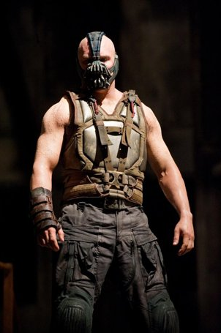

<http://movies.yahoo.com/blogs/movie-talk/early-reviews-dark-knight-rises-bane-high-marks-173841016.html>

**List of Generic characters**

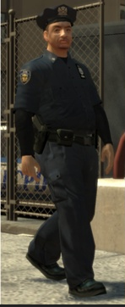 Policeman

<http://gta.wikia.com/File:LCPD-GTA4-fitcops.jpg>

Policewoman, young city woman, young city man

All character will be modelled by the group.

**Weapons**

As there are police in the game and robbers, it is natural that the game will have some weapons. The most notable weapon would be a pistol.

<http://world.guns.ru/handguns/hg/jrod/viper-jaws-e.html>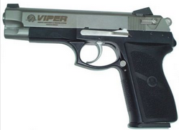

The weapon above will be used by police as they tell you to freeze. It will also be used by petty thieves and robbers in the city. The pistol will be modelled in 3d studio max.

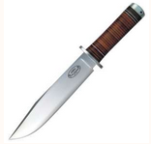<http://www.aceros-de-hispania.com/gb/infer.asp?ac=18&trabajo=listar&pa=fallkniven&sg=fallkniven>

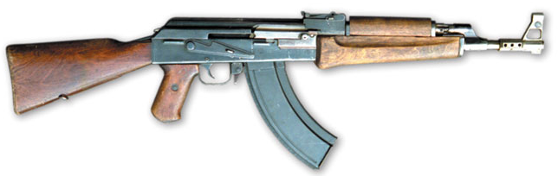The second weapon would be a knife; this would be used by various criminals in the game and again will be modelled in 3d studio max.

<http://world.guns.ru/assault/rus/ak-akm-e.html>

The third weapon will be an ak47; this weapon will be used in more serious combat between police and higher criminals. The weapon will be modelled in 3d studio max. With enough time the weapon inventory will be expanded to include a number or weapons such as grenades and machine guns.

**Pickups**

Through points of the games the player will be able to pick up certain things. Below are the most important things we hope to include into the main gameplay.



<http://www.firstaidwarehouse.co.uk/xpp-rh2_first_aid_kit.html>

The game will include various combats and so our player is likely to become injured at times. We will include a health pick up which will increase the player’s health by 25%.

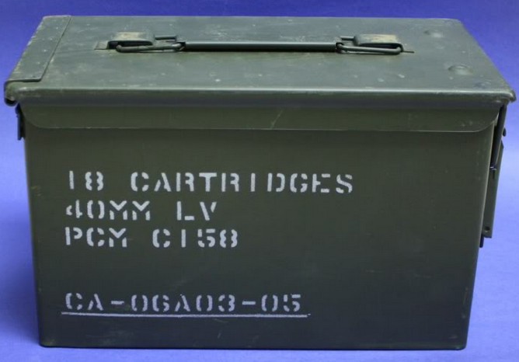

<http://www.bocn.co.uk/vbforum/threads/50822-40mm-Ammunition>

Ammunition boxes will be placed throughout the city for our characters to pick up and use with their weapons. **Vehicles**

**Level design**

Using a feature in blender we hope to initially create a city. Then taking it into 3ds max we hope to create a number of buildings and environments that the player can interact with.

Some of these include banks, tower blocks, apartments and a subway station.

Some inspiration for the subway station will come from the game Max Payne:

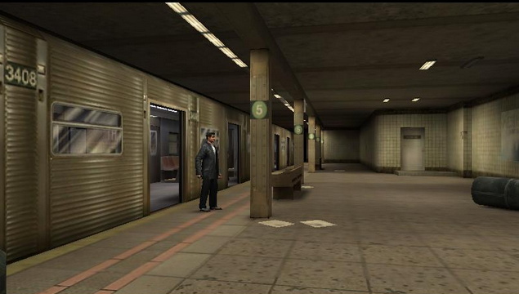

<http://maxpayne.wikia.com/wiki/Roscoe_Street_Station>